WPM2018 User manual

Contents

Node-Red Dashboard 4

1.Get started with dashboard. 4

2.Homepage 5

1.Add power meter to zone 5

2. Total power of zone 5

3.Pavg/min of zone 5

4. Total power of each power meter 6

5. Peak power 7

3.Power meter page 7

1. The meter UI 8

2. Meter configurations 9

3. Energy profiling 10

4. Google spread sheet 10

5. Minute and Hour resolutions 11

6. Weekly, Monthly, Year resolution 11

4. Control page 11

5. Netpie freeboard 12

Netpie IoT cloud platform 13

1.Meter UI 13

2.Setup your own Web interface 14

3.Backup your web interface 16

4. Advance setting 17

1.Add new widget 17

2.Lear more about netpie 17

Google spread sheet 18

Windows Form Application 19

1.Installing application. 19

2. Add new meter 19

3. Multiple meter view 21

5. Add meter to zone 21

2. Save setting 22

3. Data log 22

4. Netpie 22

5. Open running spread sheet. 22

TeslaSCADA 22

1. Windows version 23

1. Install application 23

2. Run application 23

2. Android Version 24

1. About 24

2. Requirements 24

3. Installation 24

4. Start 24

5.Settings 25

6. Load project on Android device 25

3. iOS version 26

1. About TeslaSCADA2 Runtime(iOS) 26

2. Requirements 26

3. Installation 26

4. Start TeslaSCADA2 Runtime 26

5. Settings 26

6. Run 26

7. Import for iOS 27

# Node-Red Dashboard

User can access web interface of power meter by web browser on <node-red-ip-address>:1880/ui

## 1.Get started with dashboard.

1.Open web browser (google chrome recommended)

2.Go to <node-red-ip-address>:1880/ui.

3.Enter username and password (Default username and password: default, default)

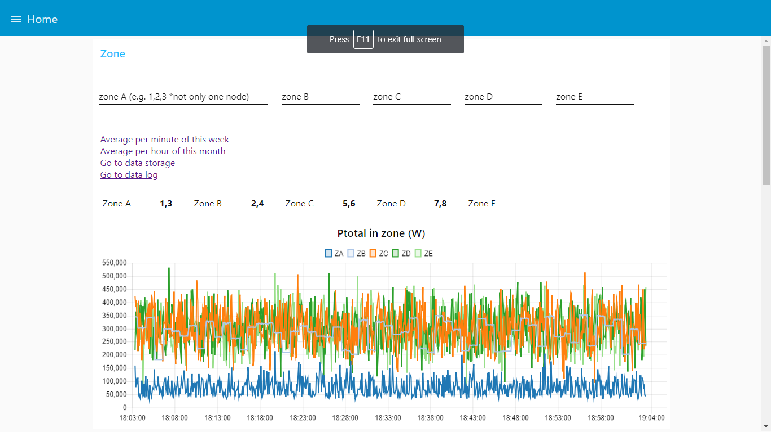

Fig.1 Homepage

## 2.Homepage

### 1.Add power meter to zone

In homepage you can set list of power meters contain in each zone e.g. zone A including power meter 1,3 zone B including 2,4 and so on. Please note that one zone should not contain only one power meter.

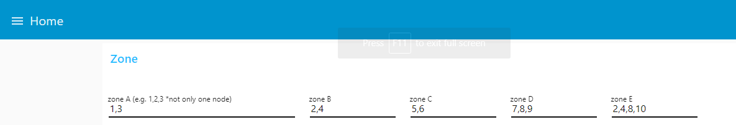

Fig.2 Zone setting

### 2. Total power of zone

Graph Ptotal in Zone will show the total power in zone. The total power will calculate every 5 second.

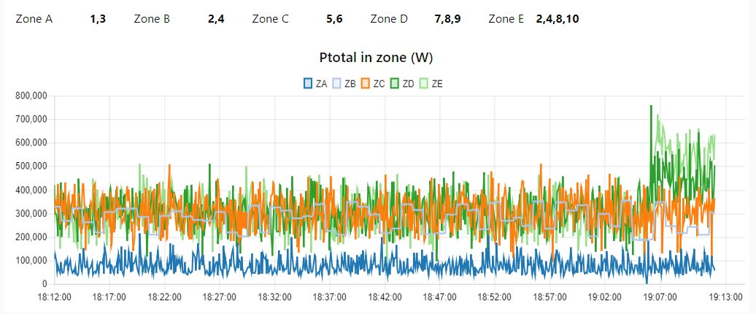

Fig.3 Ptotal in zone

### 3.Pavg/min of zone

The Pavg/min graph will display average power per minute in each zone.

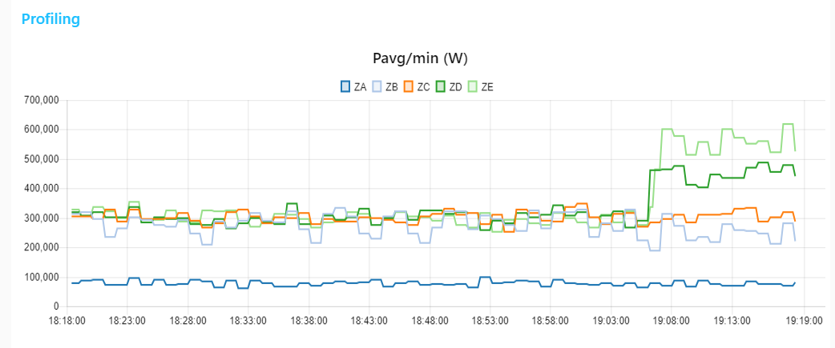

Fig.4 Pavg/min graph

You can click on label to hidden or show line graph

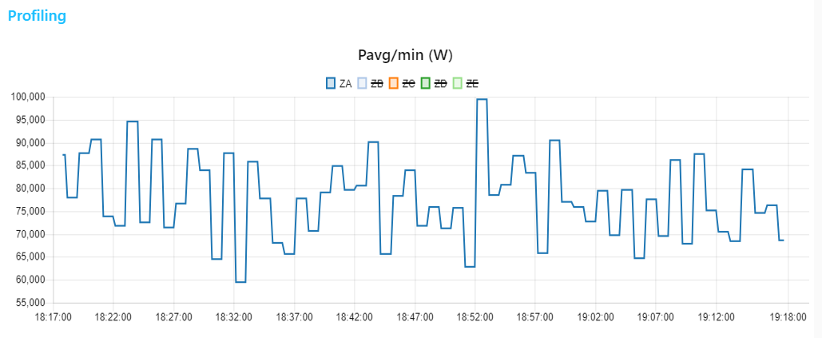

Fig.5 Show only specific graph

### 4. Total power of each power meter

Graph Ptotal is total 3 phase of power meter.

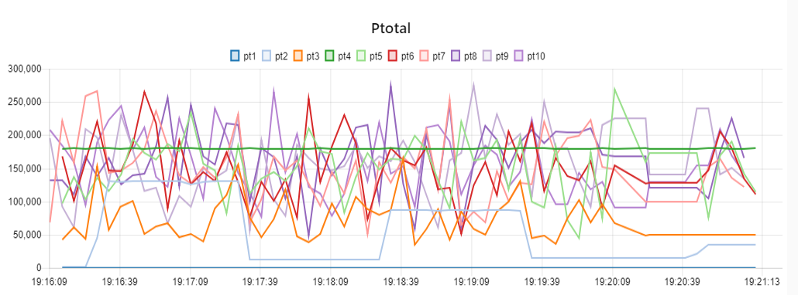

Fig.6 Total 3 phase power graph

### 5. Peak power

Graph Peak power every 15 minute is peak monitor graph. This graph will detect peak power every 15 minute

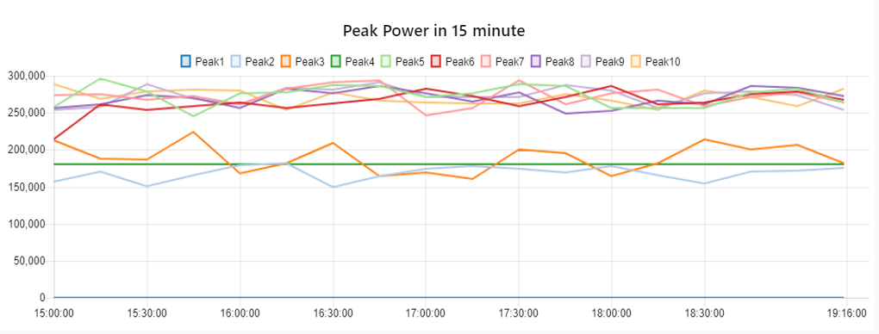

Fig.7 Peak power

## 3.Power meter page

Click icon on the upper right corner to select your meter.

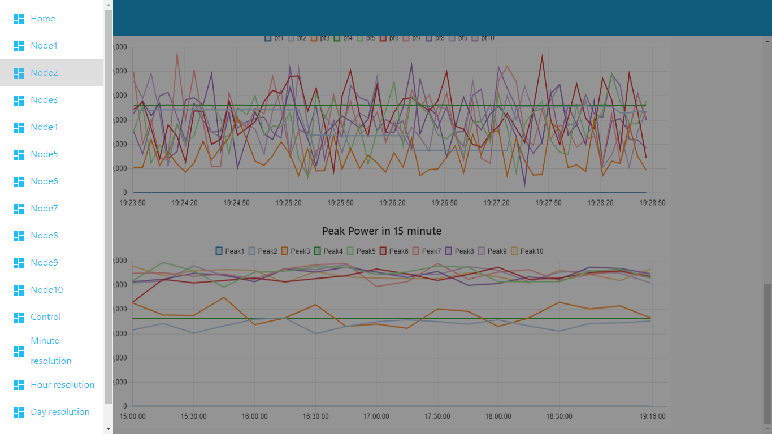

Fig.8 Select power meter

### The meter UI

This page is main page of the meter. You can check power of each phase, total 3 phases power, average power ((Pa + Pb + Pc)/3), peak power in 15 minutes pass and other detail.

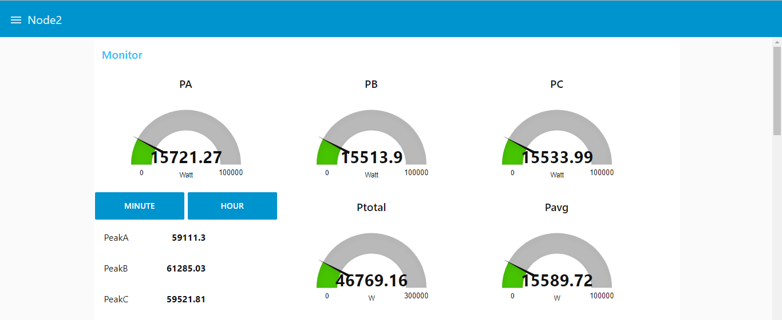

Fig.9 Power meter main page

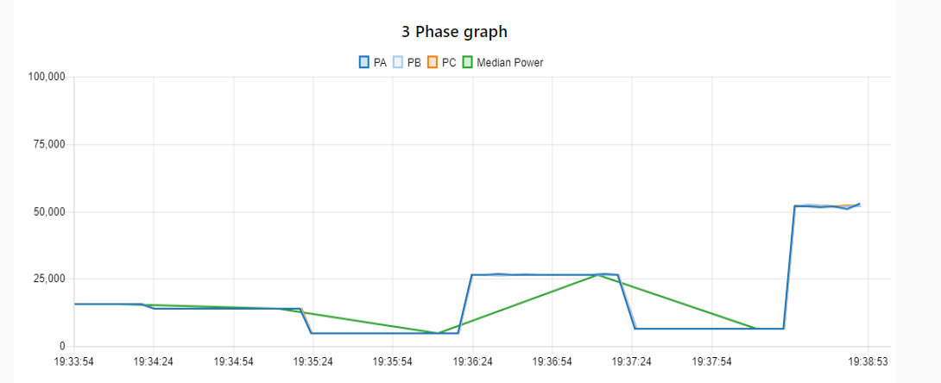

Fig.10 Power of PA, PB, PC and statistic median of all phase

The median power is use for replacing mean power in case of the peak power and the minimum power extreme difference, but if the average power still gives right meaning, the graph Power in fig. 11 showing average 3 phase power, total 3 phase power and average 3 phases power per minute

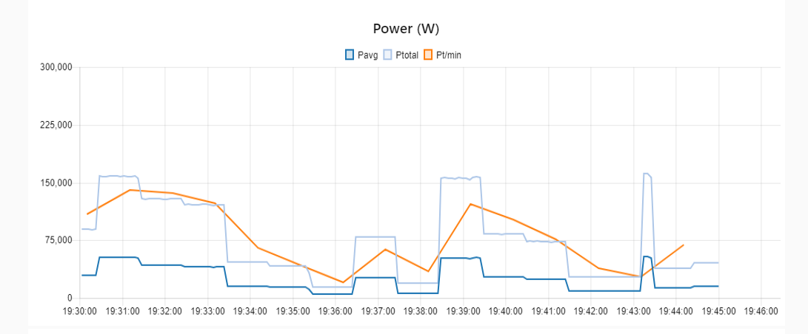

Fig.11 Average power, Total 3 phase power and Average 3 phases power per minute

### Meter configurations

To make the meter more flexible, we provide powerful parameter like enable/disable log, log interval and polling interval. Let check the meaning.

* Enable/Disable log: Set the meter to collect the data to google spread sheet or not.
* Log interval: The meter will measure and collect the data to spread sheet follow value. The value is in milli second and bigger or equal to 5000 milliseconds (Google spread sheet use https protocol, in the point of speed is not difference from http protocol, but really difference from mqtt protocols)
* Polling interval: The meter will measure and send data to broker with mqtt protocol follow this value. The value is in milli second and bigger than 1000 second. If you want to learn more mqtt protocols, please go to <http://mqtt.org/> , The mqtt really suitable for IoT application, because its speed and designed for machine to machine communication.

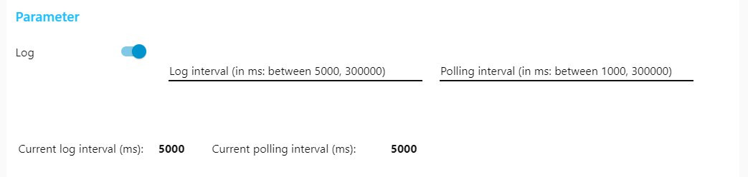

Fig. 12 Meter configuration

### Energy profiling

Not only provide power measuring, the additional feature is energy profiling, you can replace the old meter with this smart power meter, which provide energy per phase and total 3 phases energy; including energy used graph

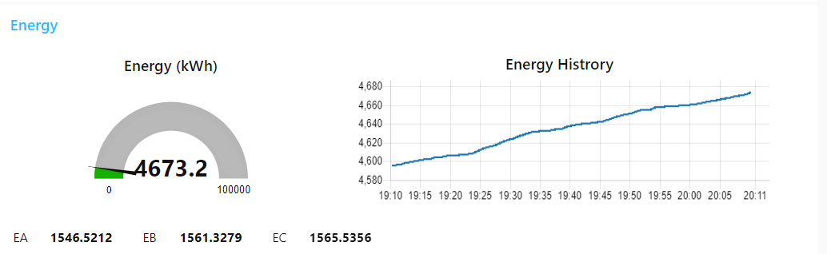

Fig.13 Energy Profiling

### Google spread sheet

Click on “Go to Log” to open the google spread sheet data log. This log are follow the meter configuration and backup to the google drive every day.



Fig.14 Link to Google spread sheet

### Minute and Hour resolutions

The profiling of data every minute are available. To check the power in every minute we provide average power in minute of each phase. You can redirect by click on Minute button. Not only minute resolution, Hour resolution are included, just click on Hour button.

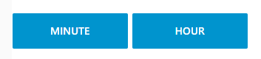

Fig.15 Minute resolution and Hour resolution button

### Weekly, Monthly, Year resolution

In case of data concluding, like the check the power in one week, one mount or one year. You can go to homepage and click on these buttons to redirect to Google spread sheet. The spread sheets are divided into two types, in this case, first is the average power per minute of the power meter which back up every week. The second is the average power per hour of the meter which back up every month

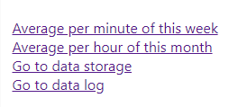

Fig.16 Data Storage

## 4. Control page

This page you can check the energy of each meter. Go to energy log by click on energy log button.

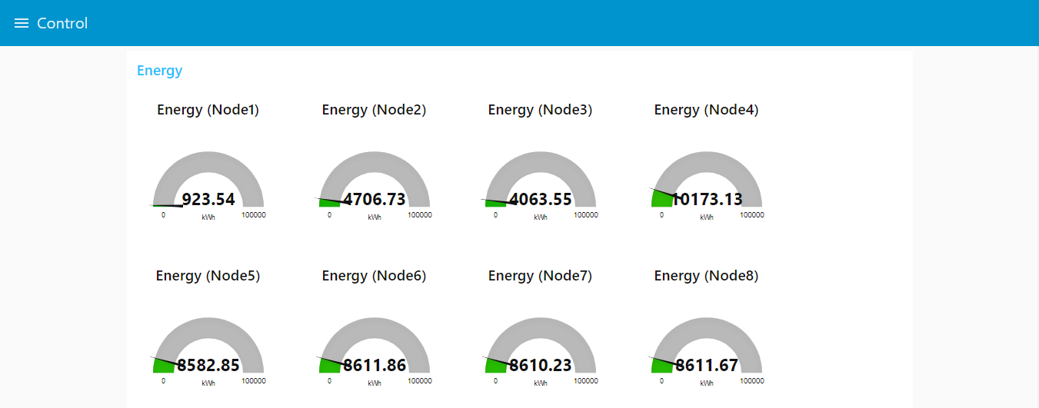

Fig.17 Kilo Watt Hour Meter

## 5. Netpie freeboard

The peak power will be collect to netpie feed every 15 minutes (Go to next topic for more information about netpie). Status of Peak power, Power and Energy also able to check in netpie freeboard. Go to netpie freeboard by click on Feed.

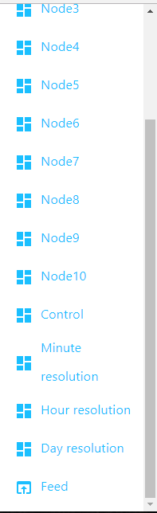

Fig.18 Netpie Freeboard

# Netpie IoT cloud platform

NETPIE platform is a cloud-based platform-as-a-service that facilitates interconnecting IoT devices (“things”) together in a most seamless and transparent manner possible by pushing the complexity of connecting IoT devices from the hands of application developers or device manufacturers to the cloud.

## 1.Meter UI

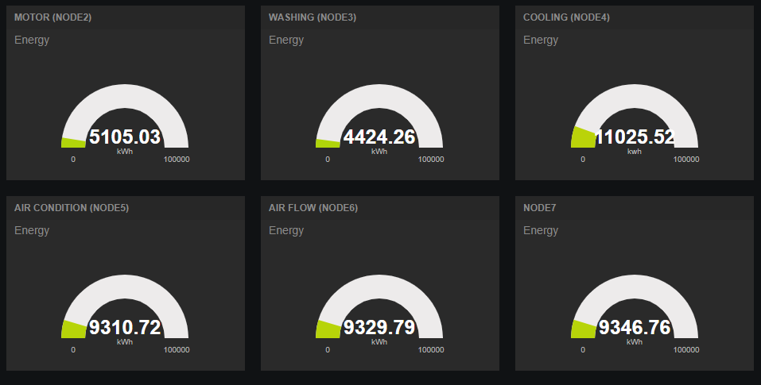

Fig.19 Netpie freeboard: kWhr meter

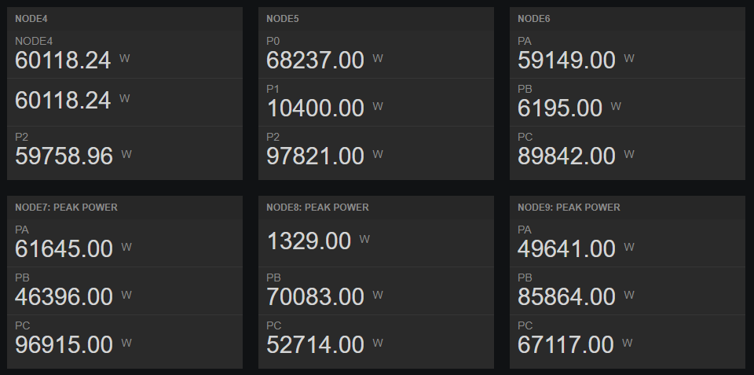

Fig.20 Peak power every 15minutes

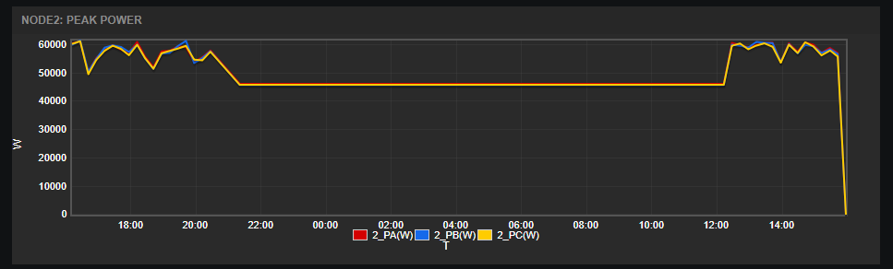

Fig.21 Peak power graph

## 2.Setup your own Web interface

Click on setting button  on top of page. You will see list of data source. Click on wpm2018feed to open setting.

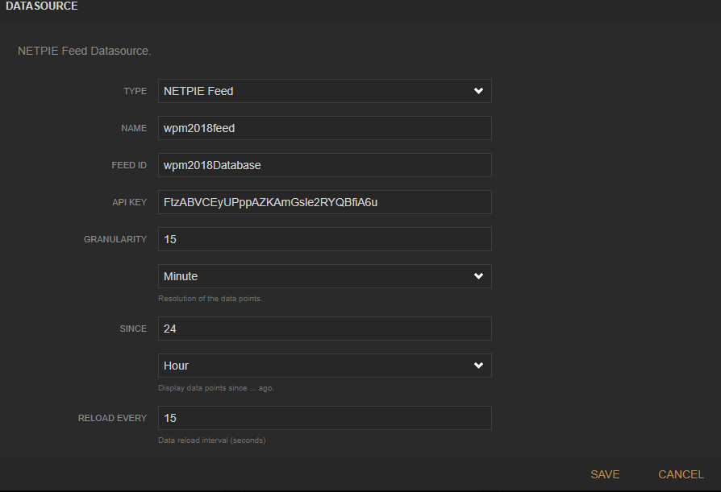

Fig.22 Peak power graph setting

In this page allow user to set up data source of peak power graph. Granularity is data resolution. User can change spanning of graph by set SINCE value. SINCE value can select to Second, Minute, Hour, Day, Month or Year.

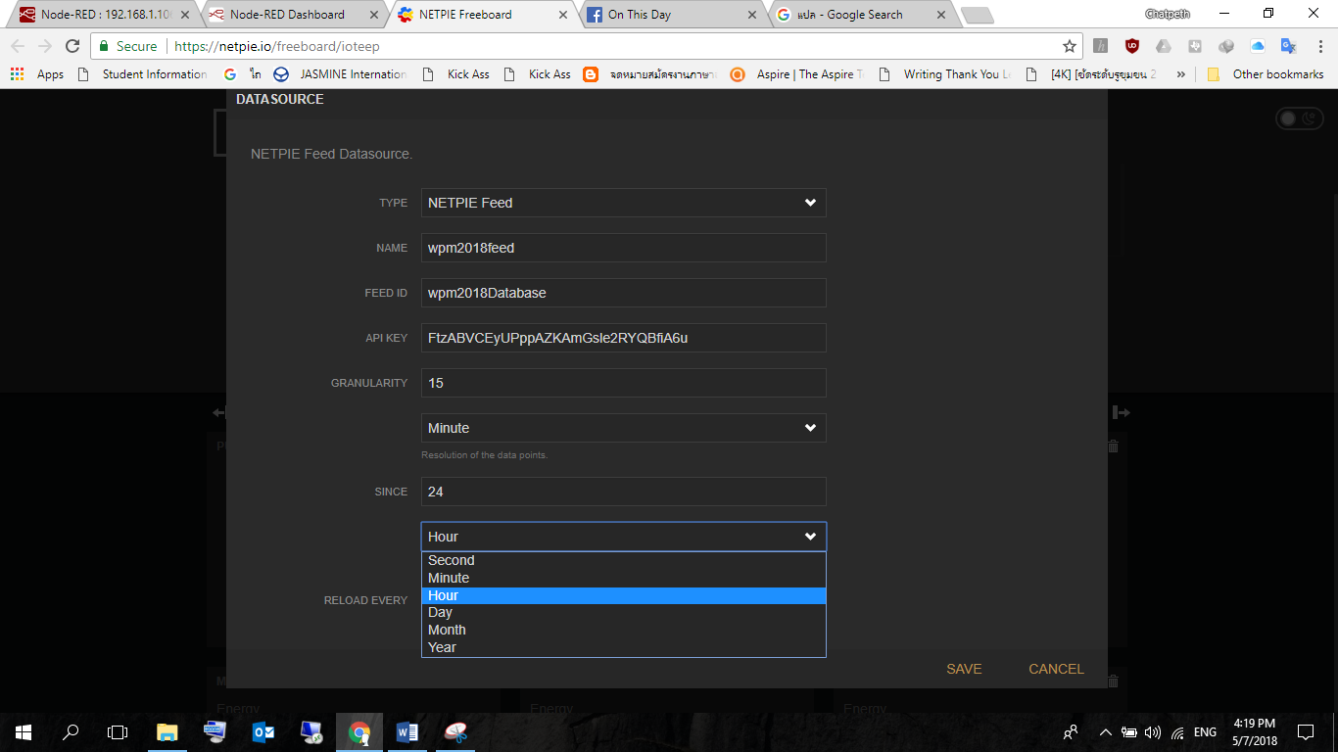

Fig.23 Peak power graph resolution.

Change the maximum value of kWhr meter by click on setting button on upper right corner.

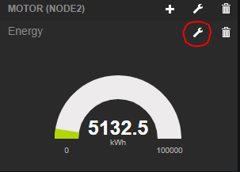

Fig.24 kWhr meter setting

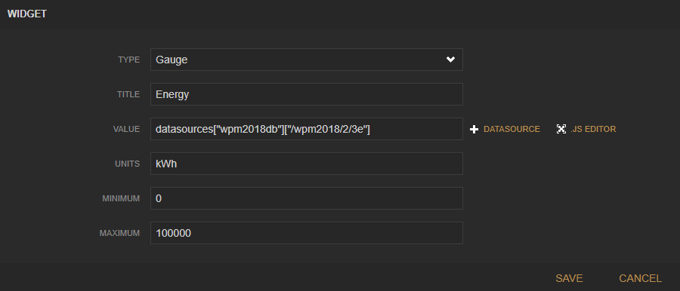

Fig.25 Maximum value of kWhr meter

User can change kWhr meter label by click on setting button on the meter pane. This label able to identify location or machine name.

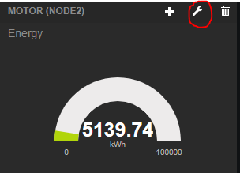

Fig.26 Meter label

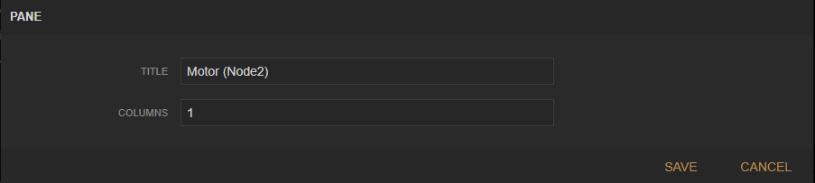

Fig.27 Change meter label

## 3.Backup your web interface

Click on setting button on upper of freeboard. Select EXPORT to back up your own interface. On the other hand, click IMPORT freeboard interface from *. json format.

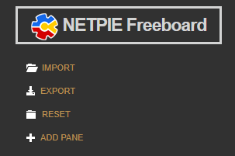

Fig.28 Back up your freeboard

## 4. Advance setting

### 1.Add new widget

Not only provide static interface. User can add new widget by click on setting->Add pane.

In your pane click on  button then select your widget type.

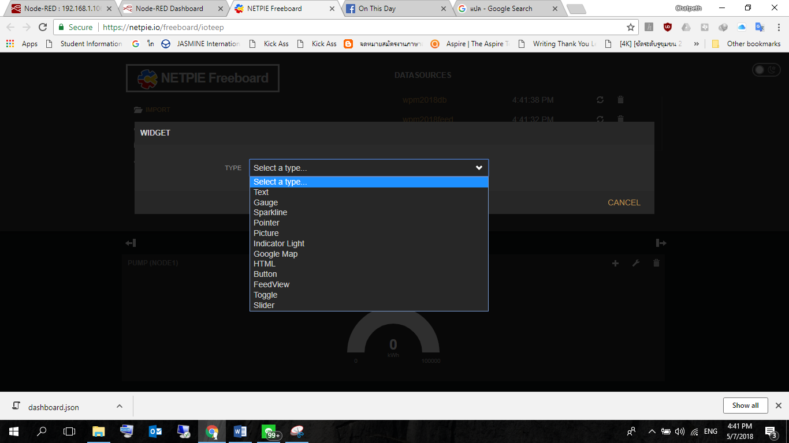

Fig.29 Add new widget

## 2.Lear more about netpie

Go to netpie website to learn more about netpie like how to create your first application, how to build data source, create netpie feed, etc.

<https://netpie.io/getstarted>

# Google spread sheet

Meter will keep data history into Google spreadsheet. User can access by click on dashboard (Go to see dashboard section). Data was time stamp by power meter on measuring time. Running sheet not allow user editing. If user would like to edit e.g. add graph, please click on export or make a copy button.

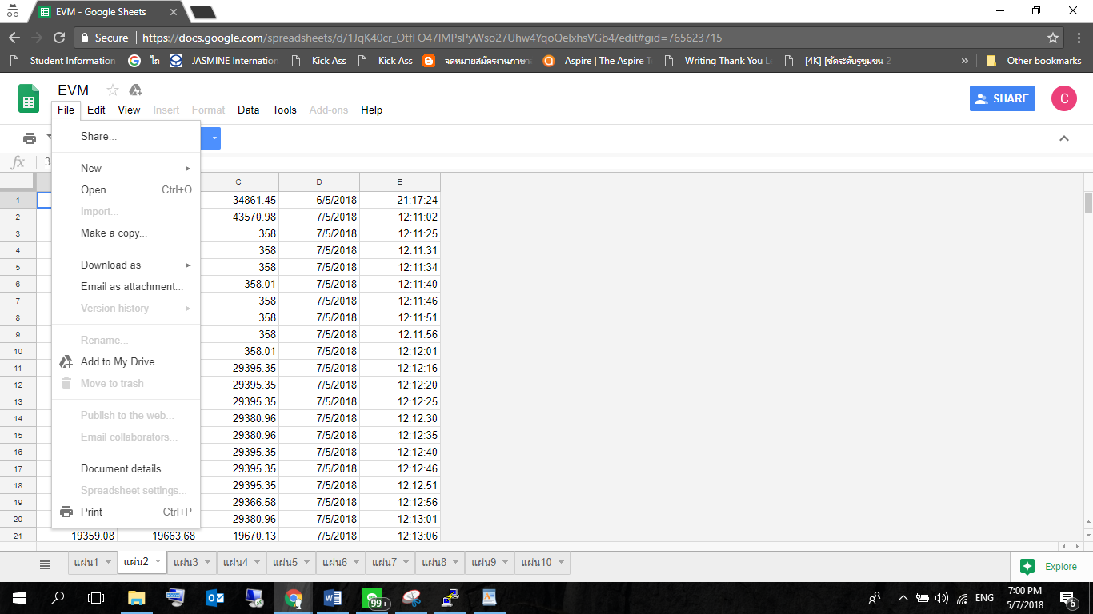

Fig.30 Export and Copy spread sheet

User must login with google account to view data on spreadsheet. We provide 4 group of Google spreadsheet.

1. Raw power which log from the meter directly. The sheet will back up every day.
2. Average power per minute which analyze and log from node-red. The sheet will back up every week.
3. Average power per hour which analyze and log from node-red. The sheet will back up every month.
4. Energy which calculate by node-red and log every day.

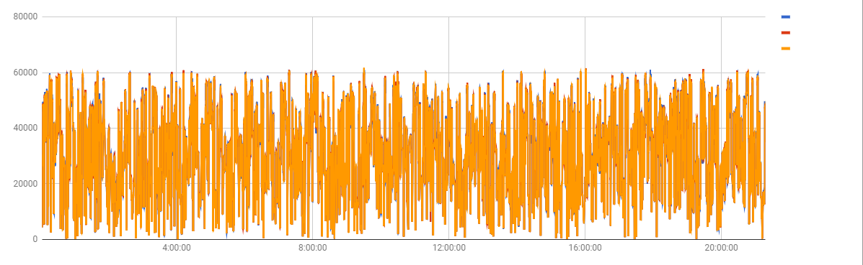

Fig.31 Insert chart to spread sheet.

# Windows Form Application

We provide Windows Form Application to allow user to connect the meter to application on windows. User can check status of meter, add meter to zone and set alarm. This application suitable for read data from meter, not for data analysis. If user prefer to add custom graph and analysis data should use Google spread sheet. In case of monitoring, suitable way is node-red dashboard or netpie free board.

## 1.Installing application.

- Extract file wpm2018a.rar to C://Program file

- Double click on wpm2018a_v1.exe

## 2. Add new meter

Insert meter ID to Node ID textbox, insert location of meter then click Add.

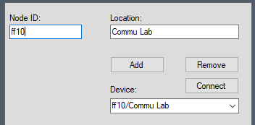

Fig. 32 Add new meter

After adding new meter, you will see status of the meter e.g. Power, Average power and Energy.

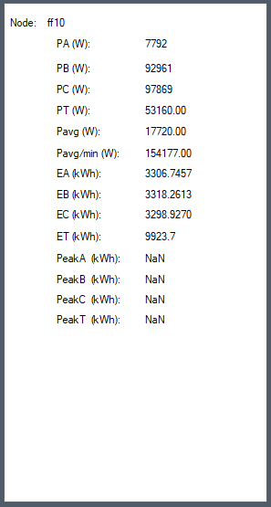

Fig. 33 Status of meter

User can select meter from device list on Fig. 34

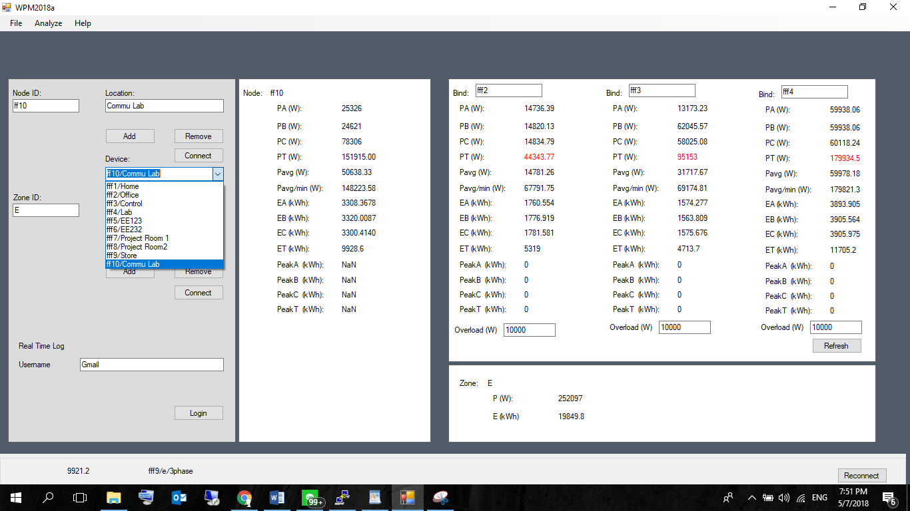

Fig. 34 Device list

## 3. Multiple meter view

User can check status of multiple meter in simultaneous by insert meter ID to Bind textbox.

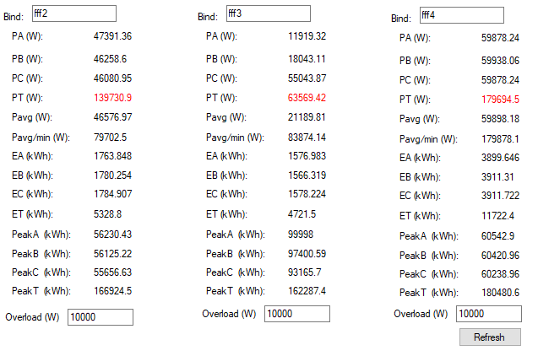

Fig. 35 Multiple meter view

User can set maximum power on Overload textbox.

## Add meter to zone

To summarize data of multiple meter, user able to add meter to zone by insert meter id and separate by comma (e.g. fff1, fff2, fff3). Click on select from device list if not prefer to type the ID by yourself, then click add.

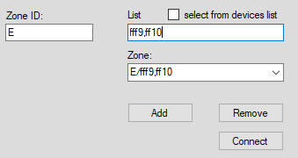

Fig.36 Add meter to zone

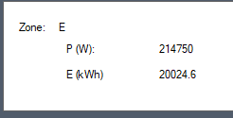

Fig.37 Zone data

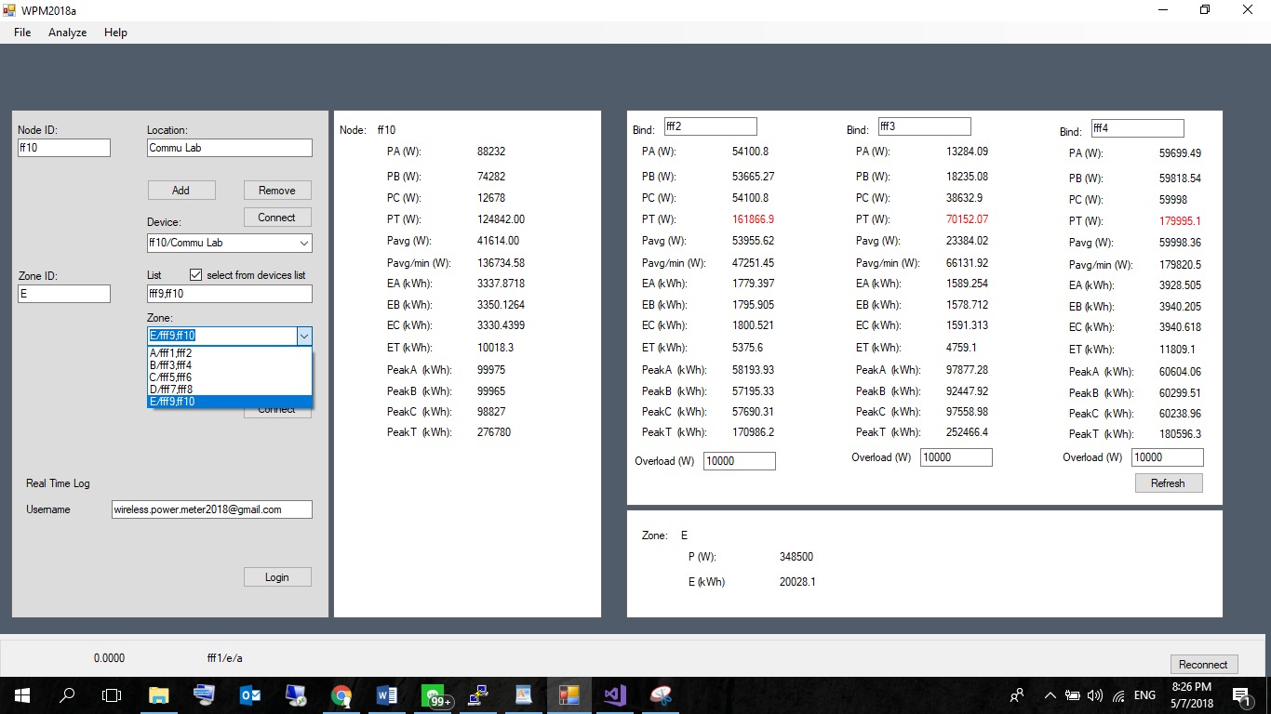

Fig.38 Zone list

## 2. Save setting

Click on File -> Save to save current configuration.

## 3. Data log

Click on File->Data log to open spread sheet folder.

## 4. Netpie

Click on Analyze->Netpie to open netpie freeboard

## 5. Open running spread sheet.

Insert username to username textbox then click login. Insert your google account to access your data.

# TeslaSCADA

TeslaSCADA is HMI/SCADA for Windows, MacOS, Linux, Android and iOS.

It is a set of native multi-platform applications and services for developing Human Machine Interfaces for real time monitoring of industrial PLC based systems and processes. TeslaSCADA products allow the control of automated processes to be extended to any device like PC, smartphone, tablet or even smartwatch.

## Windows version

### Install application

Go to <http://teslascada.com/> download application and follow installation guide on the website.

### Run application

Open TeslaSCADA run time, click File->Open, Direct to TestlaSCADA->Windows then select your meter, click run button

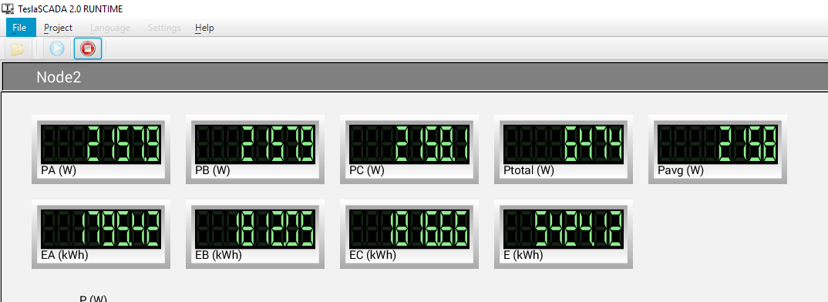

Fig.39 TeslaScada HMI

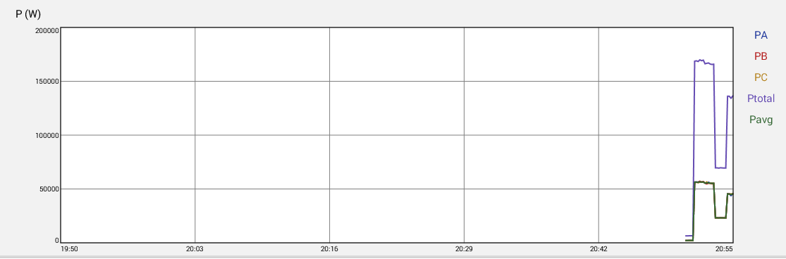

Fig.40 Power graph

Click on power graph select start and end time.

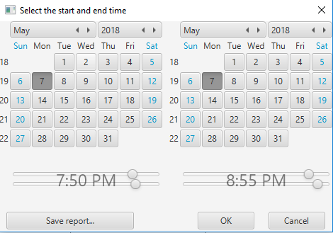

Fig.41 Graph setting

## 2. Android Version

### 1. About

TeslaSCADA2 Runtime(Android) TeslaSCADA2 Runtime is a runtime environment used for executing projects developed in TeslaSCADA2 IDE. In this manual you will ﬁnd everything you need to load and execute SCADA (Supervisory Control and Data Acquisition) project. A simple to use interface allows for easy manipulation of the project’s conﬁguration and data processing

### 2. Requirements

TeslaSCADA2 Runtime(Android) requires Android 3.0 operating systems minimum.

### 3. Installation

You can install TeslaSCADA2 Runtime(Android) in 2 ways: 1. Download and install from Google Play. 2. Download installation ﬁle (TeslaSCADA2_Android_Runtime.apk) from our site, copy it on your Android device and install.

### 4. Start

TeslaSCADA2 Runtime After opening the application you will see the main menu. Look at the picture below to brieﬂy get to know the TeslaSCADA2 Runtime interface: Main menu Run - start executing current project. Open - open project from ﬁle. Settings - application settings. About - information about application. Quit - quit application.

### 5.Settings

To set up TeslaSCADA2 Runtime settings press the corresponding button. You’ll see the following screen. Where: 1. Activate - button to activate a license. 2. Debug - check to get debug ﬁle during running application. Debug ﬁle you can ﬁnd in internal storage of Android device (or sdcard) in TeslaSCADA2Runtime/ Debug folder. 3. Full screen - check to hide status bar during execution project. 4. Swipe action - check if you want to change screen of the project by swiping gesture. 5. Sound off - check if you want to turn the sounds off. During execution project you will not hear sounds of the project. 6. Notiﬁcation - check if you want to get notiﬁcations when alarms of the project are occur. 7. Fit into screen - check if you want to ﬁt the dimension of project’s screen into dimension of device’s screen. 8. Runtime - check if you want your project starts immediately after TeslaSCADA2 Runtime starts or this project loaded.

### 6. Load project on Android device

When project is created (screens, servers, tags, scripts and users), the project can be loaded on the mobile device. For this purpose, ﬁrst the corresponding TeslaSCADA2 Runtime mobile app on the Android device must be installed and started. If the app has now been installed on the mobile device, there are 2 ways to load the project to the device. 1. Network method. 2. Manual method.

#### Network method

This method must, the PC on which the TeslaSCADA2 IDE is started, and the mobile device on which TeslaSCADA2 Runtime started and the project will be stored in a Wi - Fi network (note IP addresses) are. Procedure: 1. Enable WiFi on your mobile device where installed TeslaSCADA2 Runtime. 2. Start the TeslaSCADA2 Runtime app. 3. Open it in the editor TeslaSCADA2 IDE the desired project to be transferred. 4. Select the menu item File and Load on Device. 5. It now opens the dialog Load on Device and it will now search for mobile devices with the active TeslaSCADA2 Runtime. You can start a broadcast search and browse the entire network. However, since some routers do not forward broadcasts, there is also the possibility of a speciﬁc device search on the IP address.   This search takes a normally 5-10s. In individual cases it may happen that this search can take up to 3 minutes.   If you can’t ﬁnd a device, you can try to restart Load on Device dialog and TeslaSCADA2 Runtime application. 6. After a successful search in this dialog box all found mobile devices with active TeslaSCADA2 Runtime app will be shown. 7. Now select the desired target device and press the Load on Device button. 8. After a successful transfer, the target device with TeslaSCADA2 Runtime load new project.

#### Manual method

Another way to load a project on the mobile device is a ﬁle explorer such as: the Android File Transfer for Mac OS. Once the TeslaSCADA2 Runtime installed mobile app and once started on the sd card, a folder called TeslaSCADA2Runtime->Projects is created. Now, if the project which has been stored as. tsp2 ﬁle from the Windows, Linux or MacOS system TeslaSCADA2 IDE(The path was chosen when you ﬁrst save of the project) will be manually copied to the folder of the sd card of the TeslaSCADA2 Runtime mobile device, the app can be started normally. Now loads the app, the ﬁle from this folder by clicking Load on the main menu of TeslaSCADA2 Runtime.

## 3. iOS version

### 1. About TeslaSCADA2 Runtime(iOS)

TeslaSCADA2 Runtime is a runtime environment used for executing projects developed in TeslaSCADA2 IDE. In this manual you will ﬁnd everything you need to load and execute SCADA (Supervisory Control and Data Acquisition) project. A simple to use interface allows for easy manipulation of the project’s conﬁguration and data processing.

### 2. Requirements

TeslaSCADA2 Runtime(iOS) requires iOS 8.0 operating systems minimum.

### 3. Installation

You can install TeslaSCADA2 Runtime(iOS) in 1 way: 1. Download and install from App Store.

### 4. Start TeslaSCADA2 Runtime

After opening the application, you will see the main menu. Look at the picture below to brieﬂy get to know the TeslaSCADA2 Runtime interface: Main menu Run - start executing current project. Open - open project from ﬁle. Settings - application settings. About - information about application. Quit - quit application.

### 5. Settings

To set up TeslaSCADA2 Runtime settings press the corresponding button. You’ll see the following screen. Where: 1. Sound off - check if you want to turn the sounds off. During execution project you will not hear sounds of the project. 2. Full screen - check to hide status bar during execution project. 3. Runtime mode - check if you want your project starts immediately after TeslaSCADA2 Runtime starts or this project loaded. 4. Fit into screen - check if you want to ﬁt the dimension of project’s screen into dimension of device’s screen. 5. Swipe action - check if you want to change screen of the project by swiping gesture.

### 6. Run

When you click Run button on the main menu you’ll see screens of your project. Choose screen you want to monitor. Now you can browse through your project by clicking screen buttons of your project, using navigator button and choose screen you want and using swipe gestures (if Swipe action in Settings is On). If you want to hide (or appear again) navigator button double tap on the screen.

### 7. Import for iOS

When project is created, it can be imported for iOS mobile devices. To do import for iOS devices you should enter File and select Import for iOS. When you do it Import for iOS window will appear. To do import project for iOS devices click Import, ﬁle dialog will appear, enter name of the ﬁle and click OK. Import ﬁle has *.tsp2db extension. This ﬁle based on SQL database format and you can open and check it by using softwares for working with SQL databases. You can also open imported ﬁle by clicking Open button. Imported or opened ﬁle will be appeared in the text ﬁeld. To activate project: 1. Choose license type. 2. Enter license number. 3. Click Activate button (it will change background colour to the green and «License available for activation» message will appear). 4. If you want to deactivate license click Deactivate button (it will change background colour to the green). 5. Load project on iOS device. 6. When loading of the project is completed on iOS device «Activation completed» message will appear (device should have an Internet access). If TeslaSCADA2 Runtime has now been installed on the iOS mobile device (iPhone or iPad), there are 2 ways to load the imported project on the device. 1. Network method. 2. Manual method. Click Load on iOS device to use Network method to load imported ﬁle on your iOS device.

#### Network method

This method must, the PC on which the TeslaSCADA2 IDE is started, and the iOS mobile device on which TeslaSCADA2 Runtime started and the project will be stored in a Wi - Fi network (note IP addresses) are. Procedure:

1. Enable WiFi on your mobile device where installed TeslaSCADA2 Runtime.

2. Start the TeslaSCADA2 Runtime app.

3. In TeslaSCADA2 IDE select the menu item File and Import for iOS.

4. Open the desired imported project. Click Load on iOS device.

5. It now opens the dialog Load on iOS Device and it will now search for mobile devices with the active TeslaSCADA2 Runtime. You can start a broadcast search and browse the entire network. However, since some routers do not forward broadcasts, there is also the possibility of a speciﬁc device search on the IP address.This search takes a normally 5-10s. In individual cases it may happen that this search can take up to 3 minutes.   If you can’t ﬁnd a device, you can try to restart Load on iOS Device dialog and TeslaSCADA2 Runtime application on iOS device.

6. After a successful search in this dialog box all found mobile devices with active TeslaSCADA2 Runtime app will be shown.

7. Now select the desired target device and press the Load on Device button.

8. After a successful transfer, the target device with TeslaSCADA2 Runtime load new project.

#### Manual method

Another way to load a project on the iOS mobile device is iTunes ->File Sharing. Procedure:

1. Open iTunes on your Mac or PC.

2. Connect your iPhone or iPad to your computer using the USB cable that came with your device.

3. Click your device in iTunes.

4. In the left sidebar, click Apps. Then, scroll to the File Sharing section at the bottom of the page.

5. Select TeslaSCADA2 Runtime see which ﬁles are available for sharing in that app on your device.

6. Now you can copy your imported project (*.tsp2db) to the documents folder of TeslaSCADA2 Runtime apps.